UMCP Business Diversity Mission

The Office of Business Diversity is commited to inclusiveness in the procurement process, working with small and minority businesses to educate, connect and encourage relationships. Providing viable procurement opportunities with an overall result of being a part of the economic growth in our community. Accomplishing this through outreach, education and connecting the purchasing members of the University with businesses that desire to work with UMCP.
UMCP Commitment to Diversity

The University of Maryland College Park Campus is committed to diversity, equity and inclusion. Always seeking businesses that want to provide excellent services and or commodities.

Small Business Reserve (SBR) Program

The State of Maryland’s Small Business Reserve Program requires Maryland State Agencies, including the University of Maryland to reserve at least 15 percent of their total procurements each year for competition exclusively among Maryland certified Small Business Enterprises. The overall goal is to increase economic opportuities for small businesses.

Minority Business Enterprise (MBE) Program

In 1978, Maryland's General Assembly enacted legislation creating the Minority Business Enterprise (MBE) Program to ensure that socially- and economically-disadvantaged small business owners are included for State procurements and contracts. Current MBE regulations require State agencies to make every effort to award an overall minimum goal of 29% of the total dollar value of their procurement contracts either directly (prime contractors) or indirectly (subcontractors) to certified MBE firms.

Procurement Process

Delegated to Departments
- Up to $5K University Visa Purchasing Cards and $25K on Delegated POs
- Over $25K on Vendor Contracts

Solicitation Process
- $25K-$200K- Simplified Procurement Acquistion two or more informal quotes solicit by procurement (competed)
- Over $200K-Formally advertised on eMaryland Marketplace.
- Utilizing existing contracts (State & Higher Education Consortiums)

Business Diversity Programs with the State of Maryland Contact Information

To register for the SBR and MBE programs:
1. SMALL BUSINESS RESERVE (SBR) PROGRAM
This is a race- and gender-neutral program. eMaryland Marketplace Advantage (eMMA) (Maryland’s Procurement Portal for State agencies). https://emma.maryland.gov
eMMA Help Desk: eMMA.helpdesk@maryland.gov.
2. MINORITY BUSINESS ENTERPRISE (MBE) PROGRAM
Maryland MBE/DBE Program (Certification Program)
http://www.mdot.maryland.gov/newMDOT/MBE/Index.html
(410) 865-1269 or (800) 544-6056
UMCP and all State Agencies require minority businesses to be Maryland Department of Transportation (MDOT) Certified
University of Maryland College Park
Business Managers List web address:
www.purchase.umd.edu

Other Resources:

Procurement Contacts:
Kim Watson, Assistant Vice President watsonk@umd.edu (301) 405-5837
James Newman, Director, eProcurement & Strategic Sourcing
jvnewman@umd.edu (301) 405-3372
Rex Fitch, Director, Construction
rnfitch@umd.edu (301) 405-5818
Rex Mbuthia, Assistant Director, IT
rmbuthia@umd.edu (301) 405-7416
Vickie Underwood, Manager, Commodities and Services vunder@umd.edu (301) 405-5840
Karen Elvidge, Manager, Construction kelvidge@umd.edu (301) 405-3269
Lisa Thompson, Manager, Facilities lthompso@umd.edu (301) 405-7554
Jason Winings, Supervisor, IT
Jwinings@umd.edu (301) 405-3853

Business Diversity Contact:
Yvette Williams, Coordinator, Business Diversity bizdiversity@umd.edu (301) 405-6055

College Park Small Business Resources:
Small and Disadvantaged Business Development Center (SBDC) College Park
www.mdsbtdc.org - online appointment scheduling (301) 403-8300
Procurement Technical Assistance Program (PTAP), College Park
For assistance with Federal, State, Local Contracts www.mdptap.umd.edu
(301) 403-2740

UNIVERSITY OF MARYLAND COLLEGE PARK
The Office of Business Diversity
2113-R Chesapeake Building
4300 Terraping Trail
College Park, Maryland 20742
Procurement and Strategic Sourcing Office:
Phone (301) 405-5813
Fax (301) 314-9565
Email: bizdiversity@umd.edu
www.purchase.umd.edu

The Flagship Institution of the University System of Maryland
College Park, MD 20742, USA · 301.405.1000

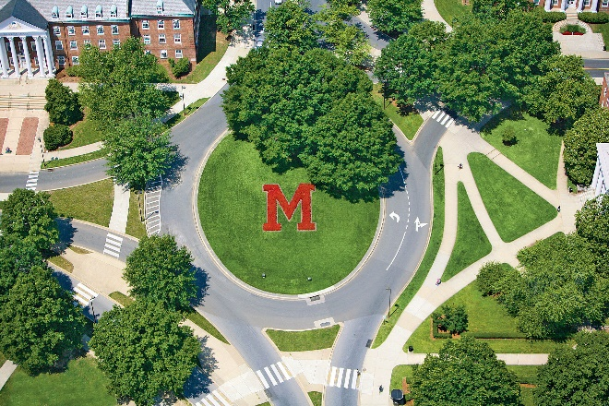
MARYLAND
OPEN FOR BUSINESS DIVERSITY

OFFICE OF BUSINESS DIVERSITY

“Where businesses meet opportunities”

University of Maryland College Park

